Spark use case

**Requirement:**

Conversion of Hive queries into spark job for performance improvement,

**Data preparation/ingestion:**

Since data is already available in PostgreSQL server, we are going to extract the data from server through JDBC call and save into temp table in spark memory using below code

As there are more than one table for data ingestion instead of rewriting the code, have looped the JDBC call and it read the table names from list provided and extract it recursively

tablename_list = ['cust_info_s','trans_info_s','offer_info_s']

url = "jdbc:postgresql://localhost:5432/postgres"

reader = (

sqlContext.read.format("jdbc")

.option("url", url)

.option("user", "postgres")

.option("password", "puvi")

.option("driver", "org.postgresql.Driver")

)

for tablename in tablename_list:

reader.option("dbtable", tablename).load().registerTempTable(tablename)

**Data check of source:**

sqlc = SQLContext(sc)

sqlc.sql("select * from cust_info_s").show(10)

sqlc.sql("select * from trans_info_s").show(10)

sqlc.sql("select * from offer_info_s").show(10)

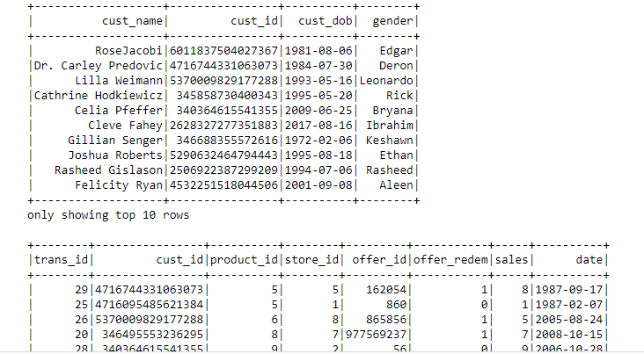

**Data transformation:**

Implementing business logic and transformation of data according to the requirement’s,

df_transf = sqlc.sql(""" WITH sales_data AS ( select sum(sales) as total_sales,count(trans_id) as visits,cust_id,date

from trans_info_s

group by date,cust_id),

offer_data AS (

select count(o.offer_id) as no_offer_received,sum(offer_redem) as no_offer_redem,o.cust_id

from offer_info_s o

inner join trans_info_s t

on t.cust_id = o.cust_id

group by o.cust_id order by o.cust_id)

select b.date,b.cust_id,a.cust_name,a.cust_dob,

int(datediff(current_date(),TO_DATE(CAST(UNIX_TIMESTAMP(a.cust_dob,'yyyy-MM-dd') AS TIMESTAMP)))/365) as age,

total_sales,c.no_offer_received,c.no_offer_redem,visits, date_format(to_date(b.date),'E') as days,

int(date_format(to_date(b.date),'w')) AS week_number

from cust_info_s a

left join sales_data b

on a.cust_id = b.cust_id

inner join offer_data c

on b.cust_id = c.cust_id

group by b.date,a.cust_id,b.cust_id,a.cust_name,a.cust_dob,c.no_offer_received,c.no_offer_redem,total_sales,visits,days

order by a.cust_id

""")

final_dfs = df_transf. orderBy('cust_id'). groupby('cust_id','cust_name','age','date','days','no_offer_received','no_offer_redem','total_sales'). pivot('days').max('no_offer_received').fillna(0)

#Sampling data - In case of job failure data can be viewed in Spark UI

final_dfs.show()

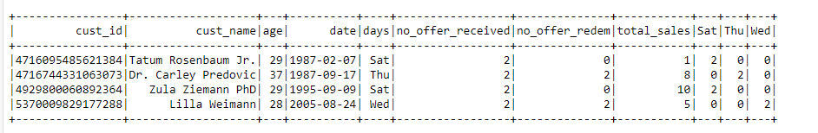

**Data Loading:**

Loading the final data frame into single CSV file using repartition.

final_dfs.repartition(1).write.mode("overwrite").option("header",True).csv("file:///C:/hdaoopdata/ics_weekly_data/")

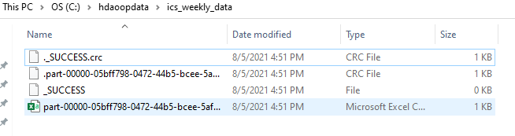

**Code base :**